**DS USING PYTHON LAB**

**EXPERIMENT: 08**

**AIM:** Recommendation system using Machine Learning

**PROBLEM STATEMENT:**

1. Use any dataset
2. Use any type of Recommendation technique

**THEORY:**

**What is a Recommendation System?**

A recommendation system is a type of artificial intelligence algorithm designed to suggest items or content that a user may be interested in based on their past behavior, preferences, and other data. These systems are commonly used in e-commerce, streaming services, social media platforms, and other websites to improve user engagement, increase customer satisfaction, and boost sales.

The goal of a recommendation system is to improve user engagement, satisfaction, and loyalty, leading to increased revenue for the business. Recommendation systems are an important tool for personalized marketing and can help businesses create targeted and relevant content for their users.

**Types of Recommendation Systems:**

1. Collaborative Filtering: This technique involves recommending items based on the behavior of similar users. For example, if two users have similar preferences and have interacted with similar items in the past, a recommendation system may suggest that each user try the other's favorite item.
2. Content-based Filtering: This technique involves recommending items based on their attributes, such as genre, artist, or author. For example, if a user frequently listens to jazz music, a recommendation system may suggest other jazz musicians or albums that they may enjoy.
3. Hybrid Filtering: This technique combines collaborative and content-based filtering to generate more accurate and diverse recommendations. Hybrid filtering may use collaborative filtering to generate a set of candidate items and then use content-based filtering to rank those items based on their attributes and the user's preferences.
4. Knowledge-based Recommendation Systems: This type of system uses explicit knowledge about the user's preferences and behavior to generate recommendations. For example, a system may ask the user to answer a set of questions to determine their preferences and then suggest items based on their answers.
5. Context-aware Recommendation Systems: This type of system takes into account the user's current context, such as their location, time of day, and activity, to generate more relevant recommendations. For example, a recommendation system for a music streaming service may suggest upbeat music on a Friday evening, when the user is likely to be in a more festive mood.

**IMPLEMENTATION:**

Dataset: The dataset contains various columns such as ‘name’ of the book, its ‘Author’, ‘Class’ and the ‘Genre’ of the book.

1. Import the necessary libraries

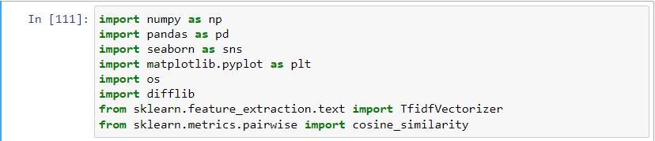

1. Import the dataset

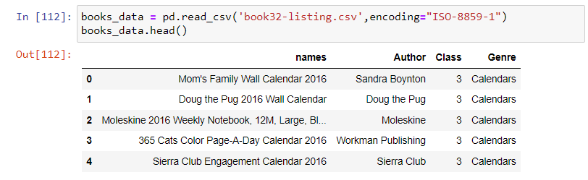

1. Dropping the duplicate and null values from the dataset. Further reducing the dataset by drop few of its values for better performance and processing

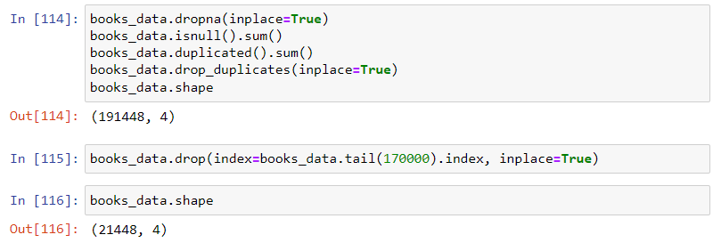

1. Removing the spaces between the words of features ‘Author’ and ‘Genre’.

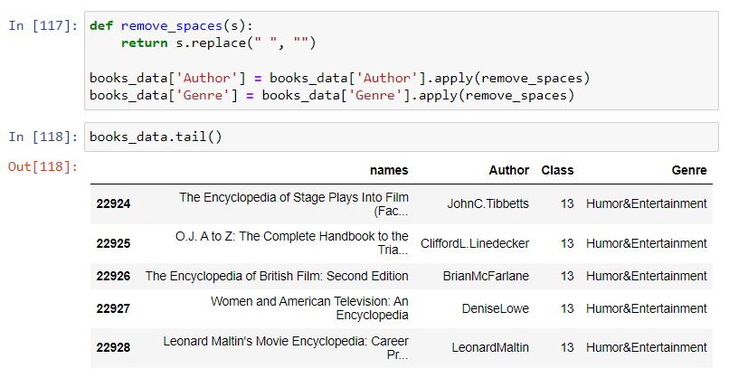

1. Further converting the same to lower case

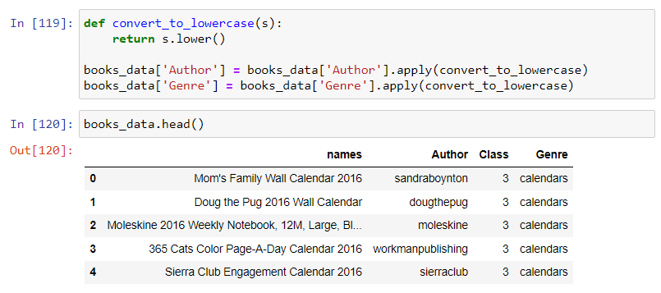

1. Introducing a new column ‘Tags’ which’ll be a combination of ‘Author’ and ‘Genre’. This will be useful for converting into vectors and calculating the similarity scores for the books.

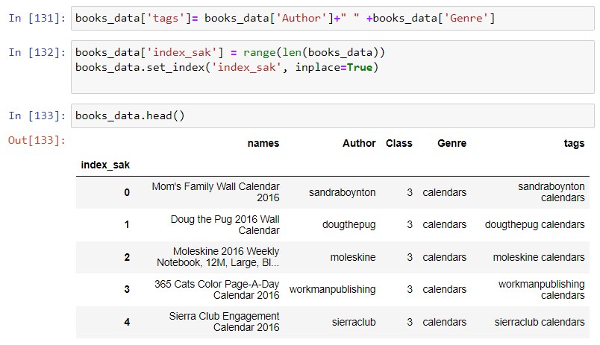

1. Converting the tags to vectors using Vectorizer function.

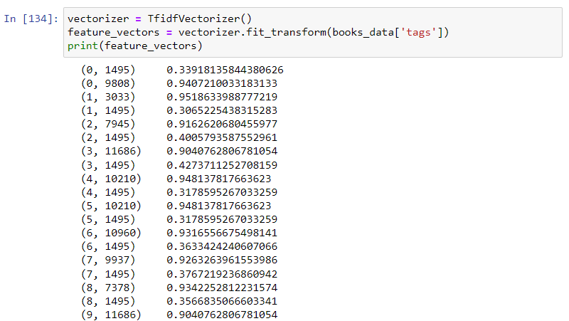

1. Calculating the similarity score of the vectors using cosine similarity.

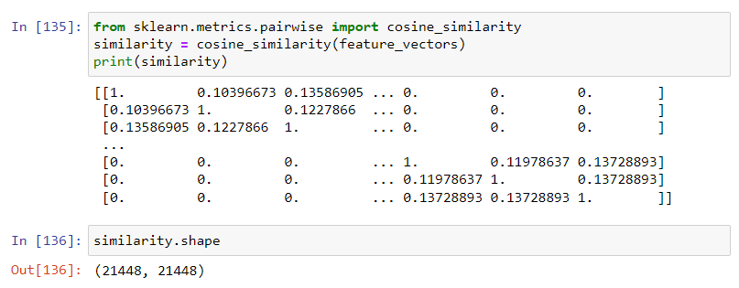

1. Taking the user input



1. Function for making the recommendations

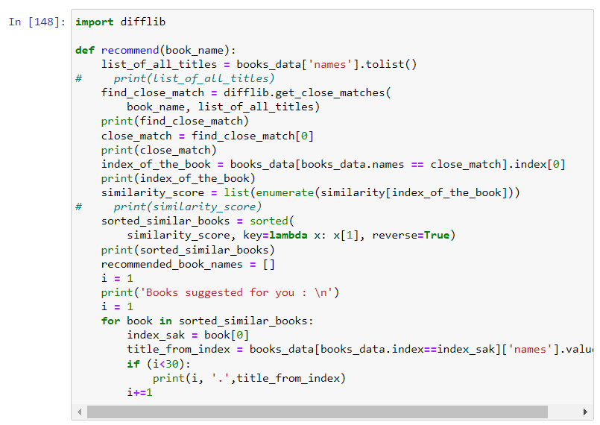

1. Actual Recommendations made by the model

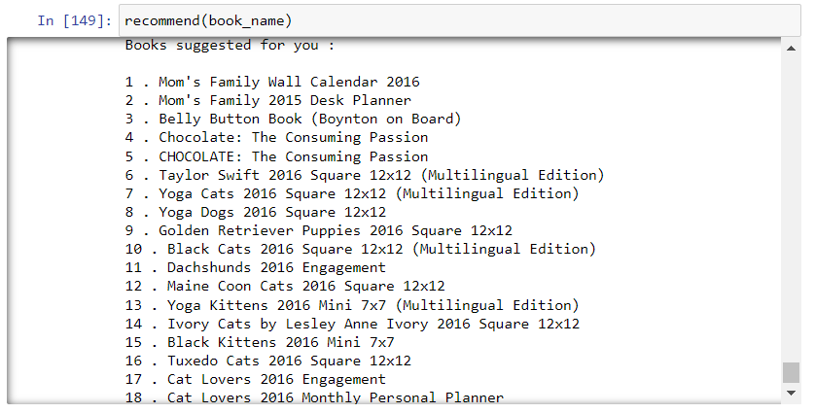

**Conclusion:**

Thus, a recommendation system using Machine Learning was implemented successfully.